Setup

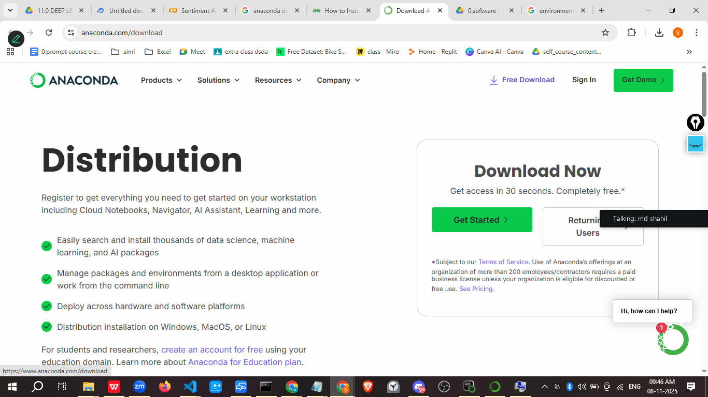

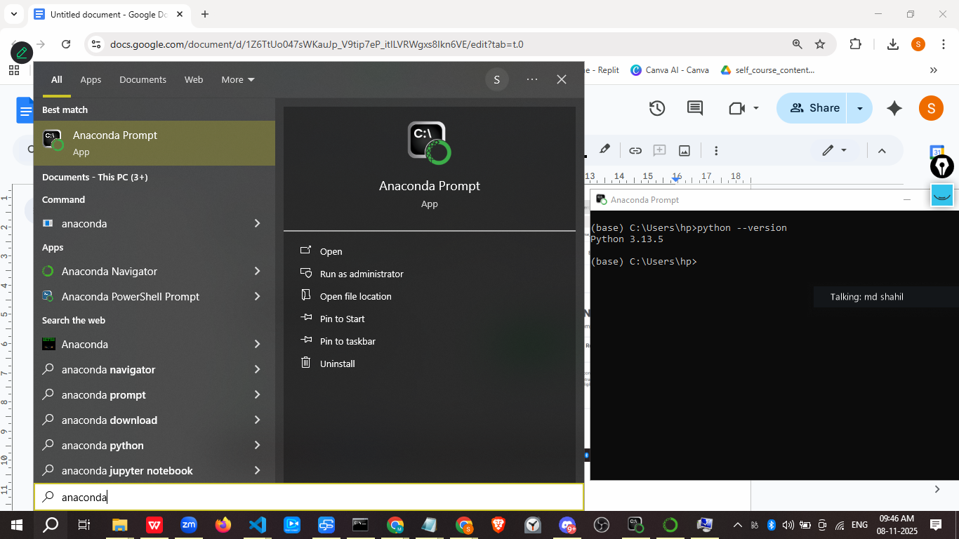

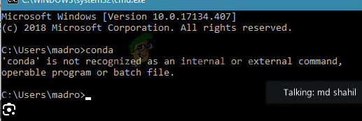

Solution

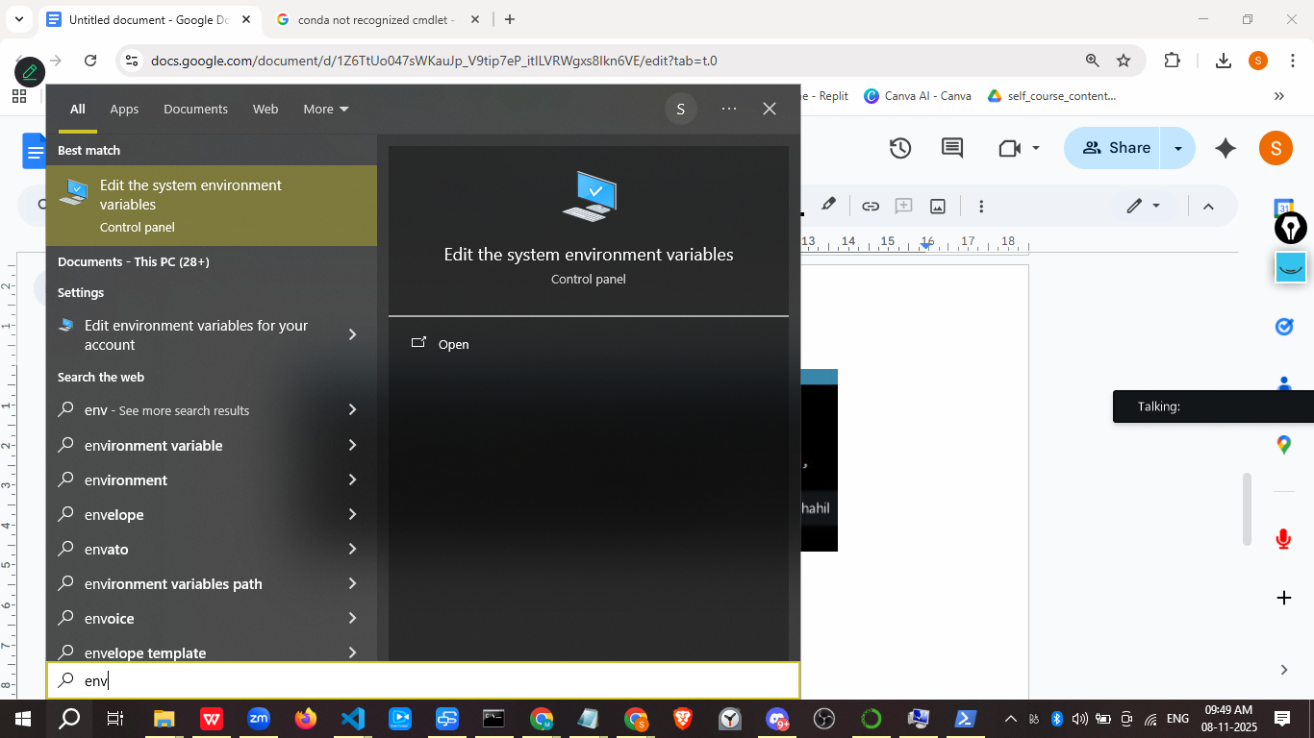

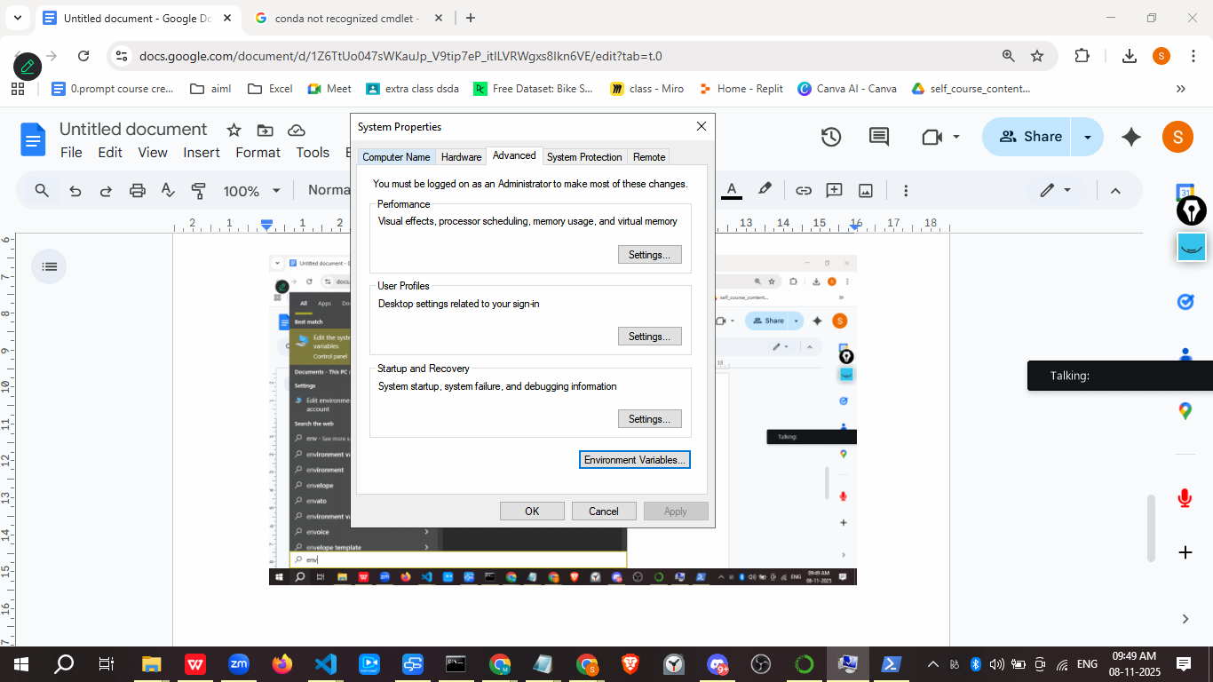

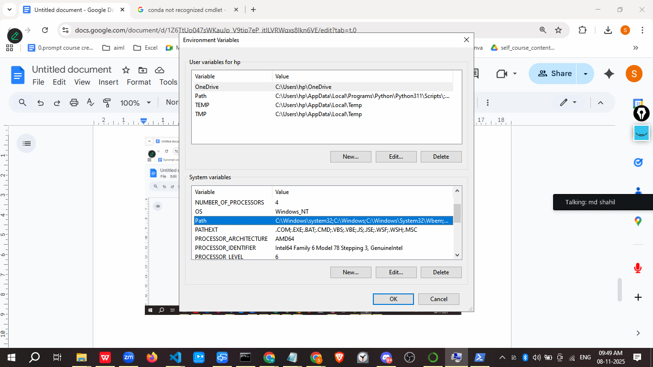
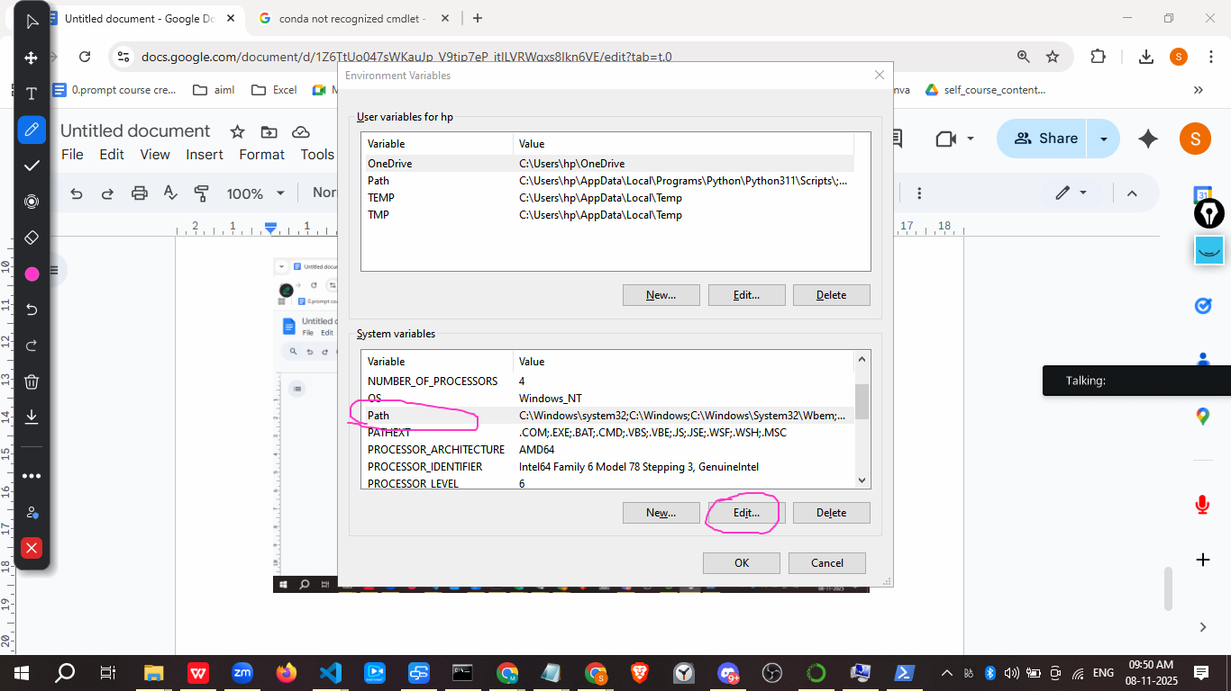

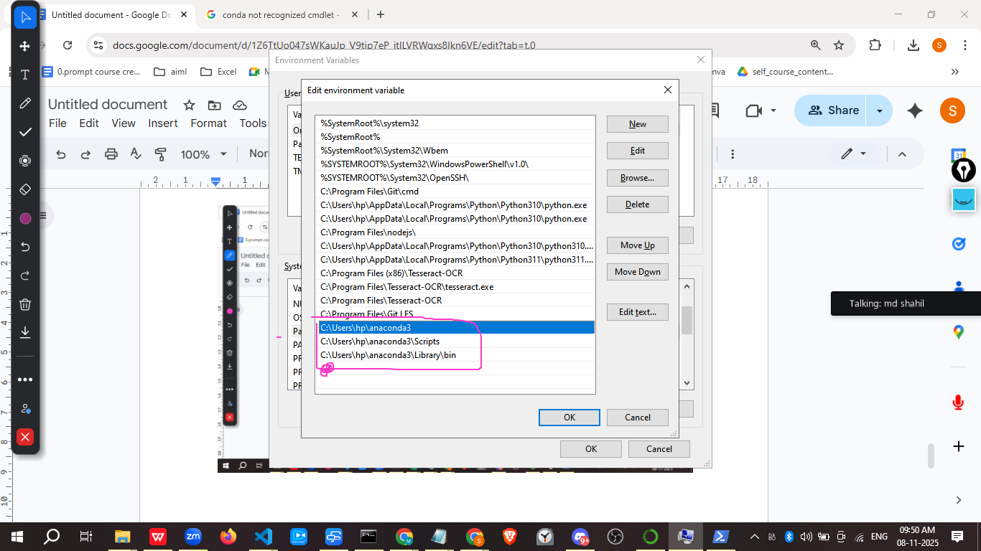

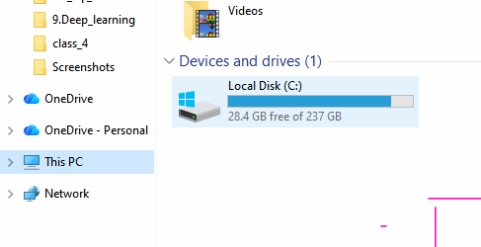
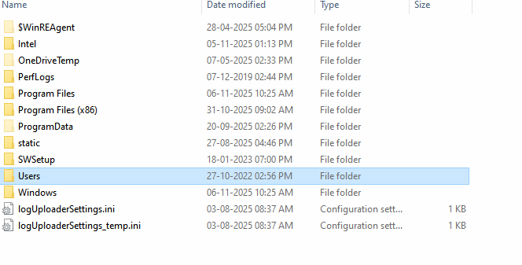
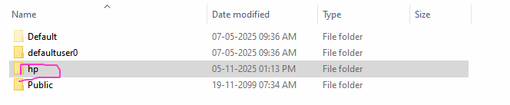

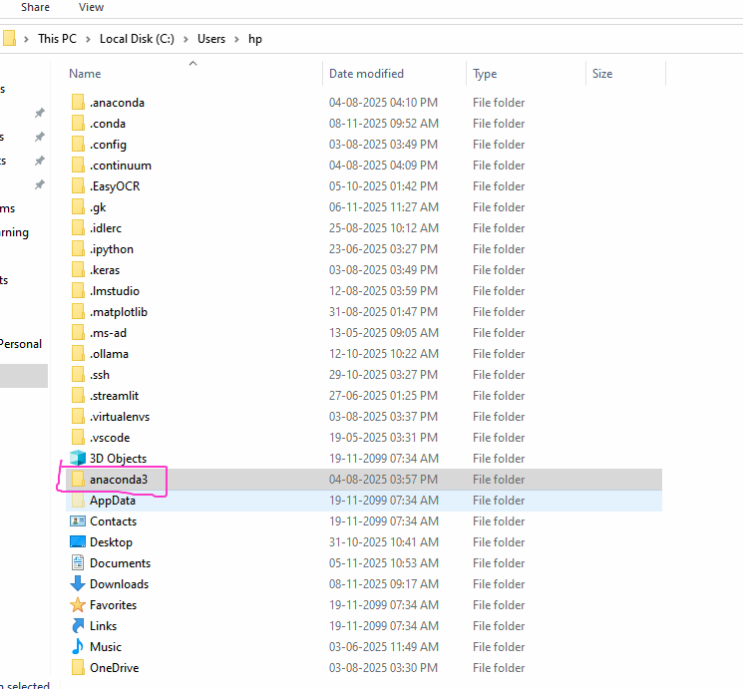

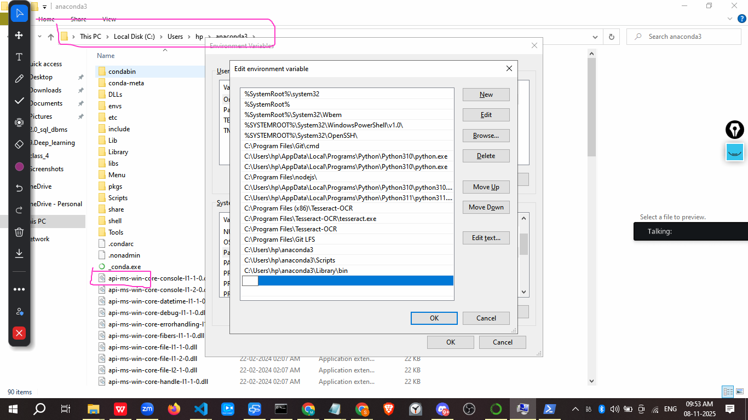
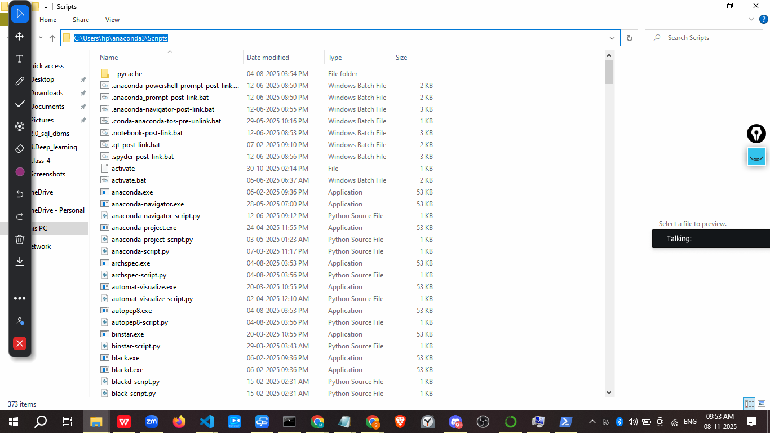
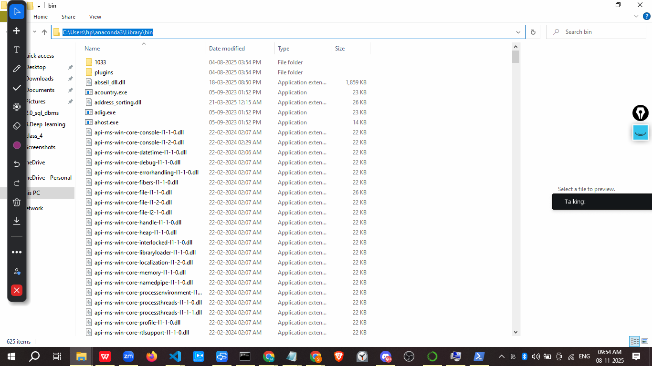

Or use program data
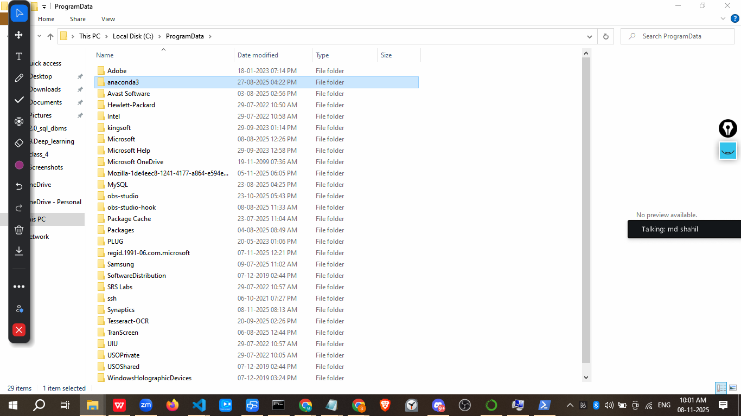

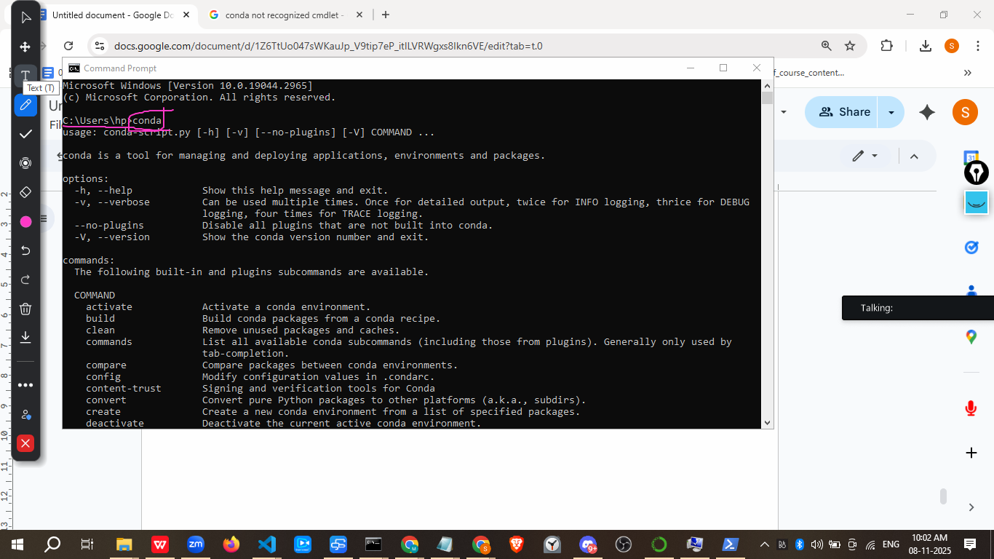

—-----------
Conda info –envs # show all environments

- Conda list – show the install library
- Conda init → for 1st time user run
- Activte the environments
– conda activate envname
Eg. Conda activate base
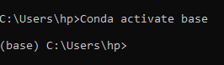

To create a new Conda environment with Python 3.10, follow these steps:
Open your terminal or Anaconda Prompt.
Execute the following command:
to create the environment, replacing myenvname with your desired environment name:

conda create -n myenvname python=3.10

- Or >conda create -n venvname310 python=3.10 -y
- -n specifies the name of the new environment.
- python=3.10 explicitly requests Python version 3.10 for this environment.
- Conda will then list the packages: it needs to install and ask for confirmation. Type y and press Enter to proceed.
- Once the environment is created, activate it: using the following command:
conda activate myenvname

After activation, your terminal prompt will typically show the environment name in parentheses, indicating that you are now working within that specific environment. You can then install any necessary packages for your project within this activated environment using conda install or pip install.

